Student’s name | …………………………………………………….…… | Grade | 1
Subject | Computer | Week No. | 9
Lesson Title | A Digital Notepad | Unit
Worksheet No. ( 9 ) (Answer)

Question A: write the correct name of each part

Folder | Search bar | Notepad | Menu

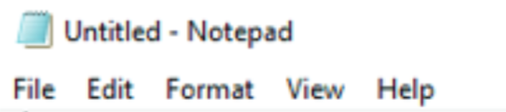
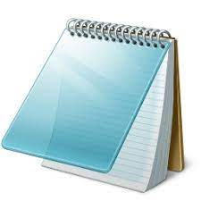
Menu
Notepad
Search bar
Folder
Good Luck

